**C.V**

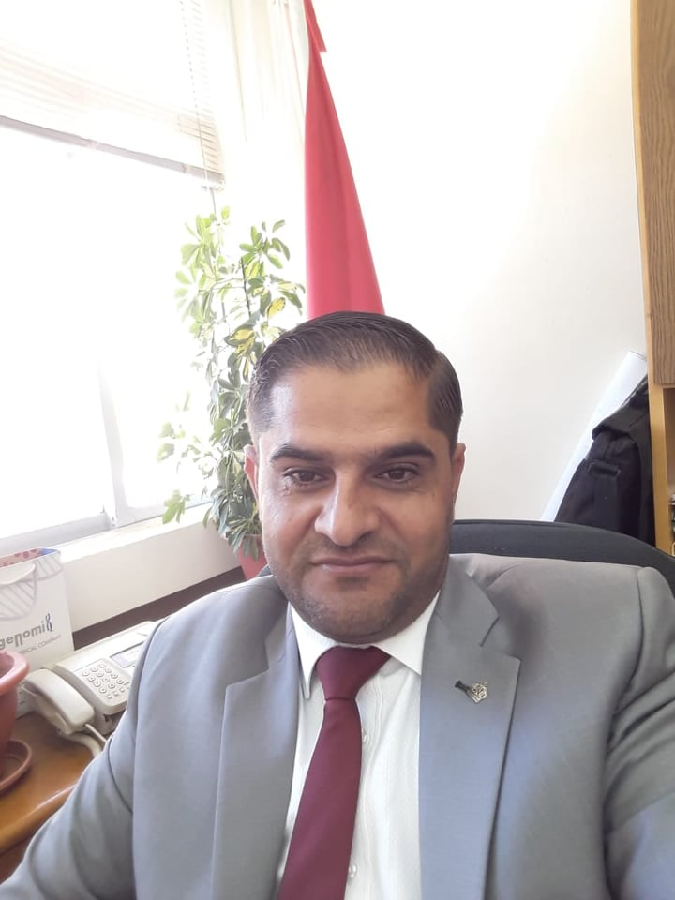

**PHONE 0096 6790767507**

**E-MAIL:** [**Majali201181@YAHOO.COM**](mailto:Majali201181@YAHOO.COM)

**IBRAHEM AL-MAJALI**

Marital Status: married.

Nationality: Jordanian.

Religion: Muslim.

Date and Place of Birth: 15/11/1982 Karak.

Address: Mutah University.

**EDUCATION**

*General Secondary Education Certificate

Examination 1999/2000 (Abedalwahab Majali School).

*Bachelor's degree in General Biology 2003/2004

(Mu'tah University).

*Master's degree in General Biology (Microbiology) 2005/2006

(Mu'tah University).

*PhD in biological science (Immunology) 2012

(Jordan University).

**MASTER THESIS TITLE**

Biodegradation of phenol by *klebsiella oxytoca.*

**PhD THESIS TITLE**

Assessment of the Antibacterial, Antioxidation and Immunomodulatory effects of *Moringa peregrina* extracts.

**Field of Specialization**

Biomedical Sciences, Immunology

**Research Interest**

Biodegradation, bioactivity, drug development and discovery, Immunomodulatory activity

**EXPERIENCES**

-Biology teacher at Mu'tah University School from 2008 -2013.

-Part time teaching at Mu'tah University 2010- 2013. (Microbiology, biotechnology, Immunology & Ecology).

- Assistance professor in Al-Zaytoonah University‏ 2013-2015 (Physiology, Physiologylab, Biology, Biology lab).

- Assistance professor in AL-Ghad International College For Applied Medical Sciences 2015- 2017.(Microbiology, Biology, Anatomy and Physiology).

-Assistant professor, Department of medical laboratory sciences, Faculty of Sciences, Mu’tah University, Jordan 2017 - 2022.

-Associat professor, Department of medical laboratory sciences, Faculty of Sciences, Mu’tah University, Jordan 2022 until now.

**University committee member**

|  |  |
| --- | --- |
| Science college council member | 2017/2018, 2018/2019, 2021-2022 |
| Inquiry students committee member | 2018 and 2022 |
| Life skills study plain preparation committee member | 2017/2018 |
| Scientific research committee member/ Department of medical laboratory sciences | 2017/2018-2018/2019 |
| Study plan committee head/ Department of medical laboratory sciences | 2017/2018-2018/2019-2021/2022 |
| Social committee head/ Department of medical laboratory sciences | 2018/2019-2021/2022 |

**Master students (Co-supervisor)**

**20199-2021** Anas Bashayreh (2021) antimicrobial, antioxidant inflammatory effect of *Varthemia iphionoides* methonolic extract

**PUBLICATIONS**

Assi, G. A., Al-Bashaereh, A., Alsarayreh, A., Al Qaisi, Y., **Ibrahim S.Al-Majali**, Khleifat, K., Alqaraleh, M., Qaralleh, H., & Al-Farrayeh, I. (2023). Evaluation of Antibacterial, Antioxidant and Anti-inflammatory Properties of Methanol Extract of Varthemia iphionoides. Tropical Journal of Natural Product Research (TJNPR), 7(1).

**Ibrahim S.Al-Majali** (2022). Antioxidant and anti inflammatory activities of Star anise (*Illicium verum)* in murine model. Biomedical and Pharmacology Journal volume 15 (2).

**Ibrahim S.Al-Majali.** (2020). Immunological Parameters in Early Detection of COVID-19 Patients with Positive RT-PCR and Evaluation of the Possible Correlation between Immunological Parameters in Jordan. Volume 54, Issue 09.

**Ibrahem S. Almajali**, Amjad Al-Tarawneh, Haitham Qaralleh,Muhamad Al-limoun, Mutaz M. Al-Sarayrah, Moath Alqaraleh,Walid Abu Rayyan, Khaled M. Khleifat, Saif M Dmour. (2021). Biodegradation of Phenol by Curtobacterium flaccumfaciens: Optimization of Growth Conditions. Pol. J. Environ. Stud. Vol. 30, No. 6, 5435-5442.

Abu Qatoosah, L., Mallah, TAE., Abu Rayyan, W., Abu Dayyih, W., **Al-Majali, IS**., Qaralleh, H., Al- Thunibat, OY., Seder, N., Bustami, M. (2018) Analytical and Comparative Study About the Impact of Lead Homeostasis on Cardiovascular Disorders in Humans. Biomed Pharmacol J 11 (1): 277-284.

WALID ABU RAYYAN, **IBRAHIM S. AL-MAJALI**, ZAINAB ZAKARIA, AHMED S.ABU-ZAITON, WAEL ABU DAYYIH. (2019). SPECIFIC PURIFICATION OF ALCOHOL DEHYDROGENASE FROM Saccharomycescerevisiae; QUALITATIVE AND QUANTITATIVE CHARACTERIZATIO. International Journal of Biology, Pharmacy and Allied Sciences IJBPAS, 8(12): 2337-2349.

MONA BUSTAMI , WAEL ABUDAYYIH, YAZAN S. BATARSEH , **IBRAHIM S. ALMAJALI** , LINA N. TAMIMI , AREEJ RAHHAL , WALID ABU RAYYAN. ( 2019). EFFECT OF SMOKING AND OBESITY ON THE SERUM LEVELS OF VITAMIN D3 IN THE CENTRAL REGION OF JORDAN. International Journal of Biology, Pharmacy and Allied Sciences IJBPAS, 8(11): 2277–4998.

Eyad M. MALLAH , Walid S.A. RAYYAN , Wael A.A. DAYYIH , Feras D. ELHAJJI , Kenza A. MANSOUR , **Ibrahim S. AL-MAJALI** & Tawfiq A. ARAFAT.(2016). Dose-Dependent Synergistic effect of Pomegranate Juice on the Bioavailability of Sildenafil in Rats by Using HPLC Method. *Latin American Journal of Pharmacy*, (*Lat. Am. J. Pharm.)* Vol **35** (6).

Moath Alqaraleh, Violet Kasabri, **Ibrahim Al-Majali**, Ahmad Aljaafreh,Nihad Al-Othman, K. Khleifat, Nafe M Al‐Tawarah, Haitham Qaralleh, Alia S. Khwaldeh,Sundus Alalawi, Mohammad al majali. (2021). Branched chain amino Acids as in vitro and in vivo Anti-OxidationCompounds. Research J. Pharm. and Tech. 14(7):3899-3904.

Moath Alqaraleh , Violet Kasabri , Ahmad Aljaafreh , **Ibrahim Al-Majali** , Nihad Al-Othman , Khaled Khleifat ,Sara Khaleel , Nafe M. Al‐Tawarah , Haitham Qaralleh , Mohammad Al-majali , Israa Yousef , Arwa Al-Khatib ,Alia S. Khwaldeh. (2021). Evaluation of the Antiglycation Effect of Branched Chain Amino Acids andPhytochemical Compounds on RAW 264.7 Cell Line and their Synergistic Effect on ColorectalCancer Cell Line Panel. Trop J Nat Prod Res, January 2021; 5(1):88-93.

Khaled M Khleifat, Haitham Qaralleh, Muhamad O Al-limoun, Enas M Al-khlifeh, Sundus A Aladaileh, Nafi Tawarah, **Ibrahim S Almajali**. (2021). Antibacterial and Antioxidant Activities of Local Honey from Jordan. Tropical Journal of Natural Product Research 5 (3): 470-477.

**Majali, I**., Qaralleh, H., Idid, S., Saad, S., Susanti, D., Taher, M. & Althunibat, O. (2015). Potential antimicrobial activity of marine sponge Neopetrosia exigua. Journal of basic and applied research 1(1), 1-13

**Ibrahim S. Majali,** Sawsan A. Oran, Mona R Hassuneh, Haitham Qaralleh, Walid Abu Rayyan, Osama Y Althunibat. Immunomodulatory effect of Moringa peregrina leaves, ex vivo and in vivo study. The following number has been assigned to it: CEJI-00477-2016-03.**Accepted** in Central European Journal of Immunology**.**

Ahmed Abu Rayyan1, Hamid El .Nourain Hamdan, Walid Abu Rayyan, **Ibrahim S. Majali**. (2016) Biological burden of Raw Vegetables in Hail City. Scholars Journal of Applied Medical Sciences (SJAMS). 2016; 4(4D):1398-1401.

**Ibrahim S. Majali**, Sawsan A. Oran, Khaled M. A. khleifat, Haitham Qaralleh, Walid A. Rayyan and Osama Y. Althunibat. (2015). Assessment of the antibacterial effects of *Moringa peregrina* extracts. African journal of microbiology (AFJM). Vol 9(51), pp2410-2414.

Osama Y. Althunibat1, Haitham Qaralleh, Sati Yassin Ahmed Al-Dalin, Muayad Abboud, Khaled Khleifat, **Ibrahim S. Majali**, Hammad K. H. Aldal'in, Walid A. Rayyan and Ahmad Jaafraa. (2016). Effect of Thymol and Carvacrol, the Major Components of *Thymus capitatus* on the Growth of *Pseudomonas aeruginosa*. JOURNAL OF PURE AND APPLIED MICROBIOLOGY, Vol. **10**(1), p. 367-374.

**Ibrahim Majali**, Osama Y. Althunibat, Haitham N. Qaralleh. (2015) Antimicrobial and Immunomodulatory activities of Moringa peregrine- MINIREVIEW. Journal of Basic and Applied Research 1 (2): 55-61

**Al-Majali, Ibrahim**., Qaralleh, H., Idid, S., Saad, S., Susanti, D., Althunibat O (2015). Potential Antimicrobial Activity of Marine Sponge Neopetrosia exigua. Journal of Basic and Applied Research 1 (1): 1-13

# Shawabkeh, Reyad; Khleifat, Khaled M; Al-Majali, Ibrahim; Tarawneh, Khaled (2007). Rate of Biodegradation of Phenol by *Klebsiella oxytoca* in Minimal Medium and Nutrient Broth Conditions. Bioremediation Journal Bioremediation Journal 11(1): 13 - 19.

Khleifat, Khaled M; Shawabkeh, Reyad; **Al-Majali, Ibrahim**; Tarawneh, Khaled (2007). Biodegradation kinetics of phenol by *Klebsiella oxytoca*: effect of carbon and nitrogen source. Fresenius Environmental Bulletin 16(5): 489-494.

Khleifat K. M, **Ibrahim Al-Majali**; Reyad Shawabkeh and Khaled Tarawneh (2007). Effect of Carbon and Nitrogen Sources on the Biodegradation of Phenol by *Klebsiella oxytoca* and Growth Kinetic Characteristics. Fresenius Environmental Bulletin, 16 (5) 1-7.

**COMPUTER EXPERIENCES**

Excellent in Windows, Word, Excel and Power Point

**REFEREES**

**Prof. Dr. Khaled Khleifat**

Dept. of Biology, Faculty of sciences, Mutah University

E-mail: [alkh_kha@hotmail.com](mailto:alkh_kha@hotmail.com)

**Prof. Dr. Sawsan AL Oran**

Dept. of Biology, Faculty of sciences, Jordan University

E-mail:  [oransaw@yahoo.com.com](mailto:alkh_kha@hotmail.com)